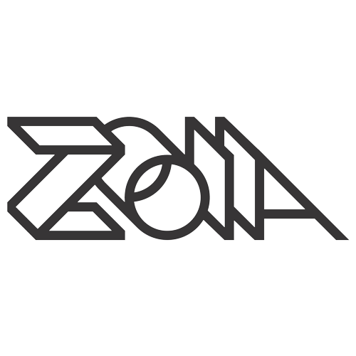

Librarian

User Manual – Beta 1

# 1.0 Welcome!

Welcome to the ZOIA Librarian! The ZOIA Librarian aims to make your life using ZOIA much easier. Whether you are a major patch creator or general ZOIA user, the ZOIA Librarian has features that can help all levels of users.

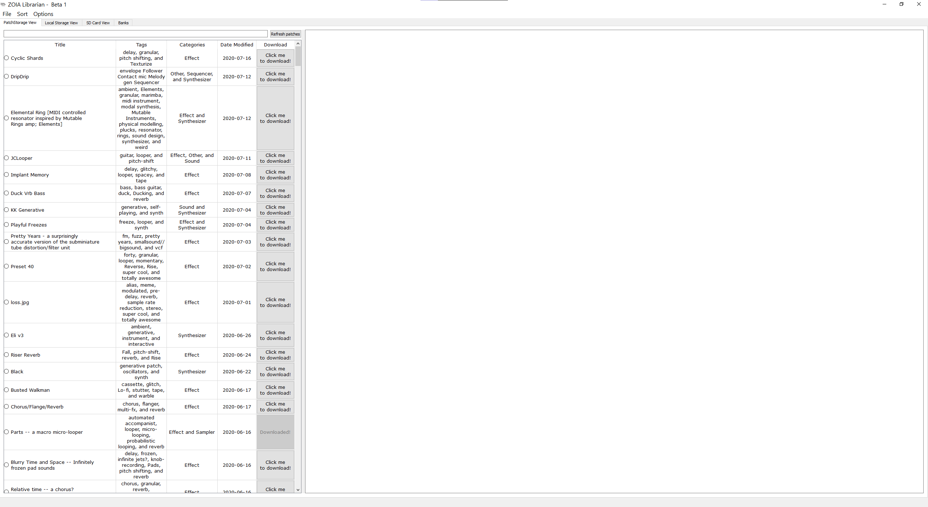The ZOIA Librarian can be launched via a single executable on Windows or a single application file on OSX. Double-clicking on the ZOIALibrarian.exe or ZOIALibrarian.app file will start the app, where after a brief splash screen you will be greeted with the following screen:

^

Please note, if this is your first time launching the application, the start-up process may take a little longer than usual as patch information is retrieved from PatchStorage. Subsequent start-ups will not need to retrieve as much information, significantly improving the start-up time.

The ZOIA Librarian is separated into 4 main tabs:



The application launches in the PatchStorage View tab. The following sections will each focus on a specific tab and go over the features contained within each.

# 1.1 PatchStorage View

The PatchStorage View tab is where you quickly browse and search through all ZOIA patches currently hosted on PatchStorage. On the left side of the screen, you will notice a table containing useful information about every patch currently available, including the title, tags, categories, and the date the patch was updated at:



Clicking on the circle to the left of a patch title will populate the right side of the screen with additional information about the patch. This shows off the author, licence, the like, view, and download count, and can even include a clickable preview link (if the patch author has included one):

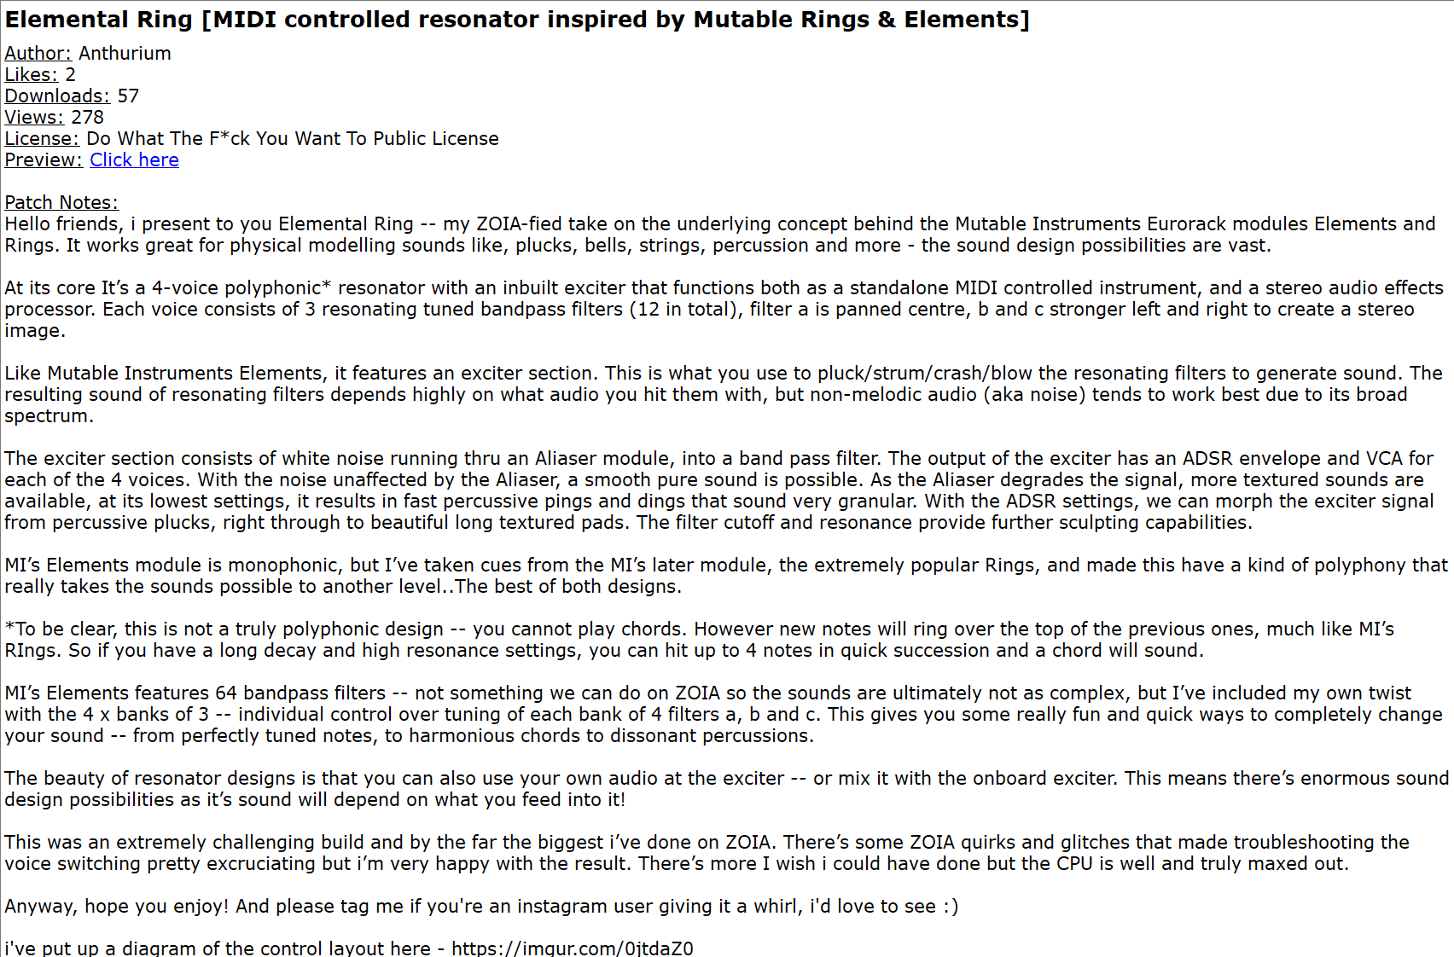

Above the table on the left there is a search bar. You can search for patches by title, tag, category, and date in the PatchStorage View tab. The Local Storage View tab allows you to also search by patch author. To initiate a search, enter what you want to search for and hit “Enter” or “Return”. For example, if you wanted to find all the patches that have “Game” in its title, tags, or category:

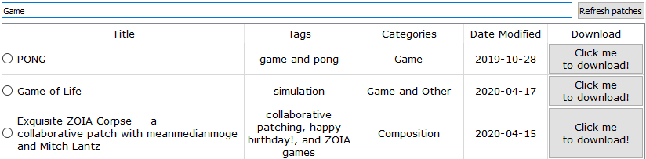

To the right of the search bar, there is a button that will allow you to refresh the patch list. It is a good idea to click this if you think you patch list has become out of sync with the patches on PatchStorage. Once it has finished, the status bar at the bottom left of the screen will display the following:

The main reason to use this tab is to explore and download patches you have an interest in! Fortunately, downloading patches is as easy as hitting the download button to the right of the patch you want to download:

Once downloading has completed, the button will update to appear grayed out. This is to make sure you do not accidently download the same patch twice. Even on subsequent launches of the application, if you have previously downloaded a patch and it still exists within a ZOIA Librarian, the button will remain grayed out:

You can view all the patches you have downloaded by switching to the Local Storage View tab, which will be covered in the next section.

# 1.2 Local Storage View

At first glance, the Local Storage View tab will look very similar to the PatchStorage View. However, there are many additional options to explore. Searching behaves just the same as it does in the PatchStorage View, except you can now also search for patches by author. Additionally, there are two new buttons to the left and right of the search bar. A “Back” button and a “Check for updates” button:



The “Check for updates” buttons will automatically check all the patches you have within the ZOIA Librarian to see if they have been updated on PatchStorage. If they have, updates will automatically be retrieved and saved. Most of the time however, this is the message you will get when clicking the button:

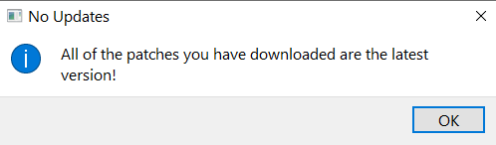

The “Back” button will initially be grayed out. Within the patch table, there are two new buttons to replace the Download button, an Export button, and a Delete Button:

Deleting a patch from the ZOIA Librarian is as quick and easy as clicking on the “X” button for that specific patch. As for exporting, this is most likely what you will see when you click on the Export button for the first time:

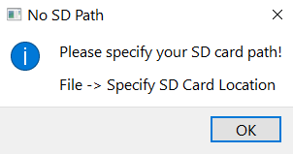

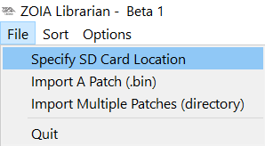To specify your SD Card location, look for the “File” option towards the top left of the screen, click it, and then click “Specify SD Card Location”:

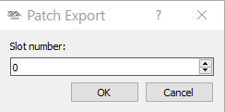After you have selected your SD card, you can now export patches. Please note that exporting from the Local Storage View tab will export to a folder called “to_zoia” by default. Clicking on the Export button again should now show the following window, where you can specify which slot you would like to export the patch to:

You will be warned if you are trying to export to a slot that is already occupied by another patch. Otherwise, the export will take place and you will be able to find the patch in the directory named “to_zoia” on your SD card.

You may notice that some patches have their Export buttons grayed out. This is because these patches were zip files and contained multiple patch files within them. The ZOIA Librarian automatically unzips these when they are downloaded. To access the Version History view, click on the circle to the left of any patch that has “[Multiple versions]” in its title:

Upon entering the Version History view for a patch, you can individually export specific versions and delete them. Additionally, the “Back” button will no longer be grayed out, so whenever you want to exit the Version History view, just click the “Back” button.

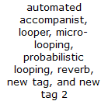On top of the features already mentioned, there are some options to edit the tags, categories, and patch notes of patches within the Local Storage View. To edit the tags or categories of a patch, simply double-click on the cell you wish to edit. Tags and categories are separated by commas. Once you have finished, simply click off the cell or hit Enter/Return:

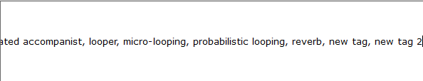

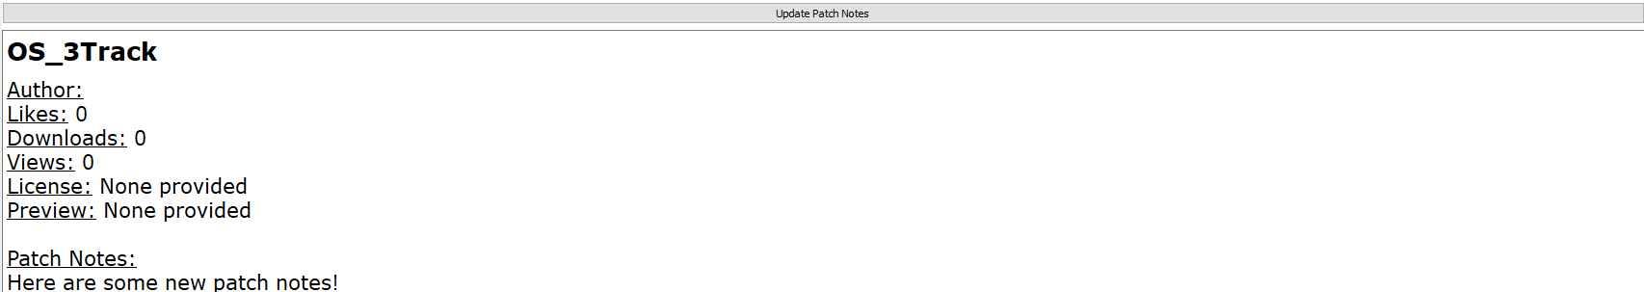To update patch notes, first select a patch on the left-hand side of the screen by clicking on the circle to the left of its name. Next, type below the Patch Notes: header:

Once you are done, be sure to save you changes by clicking the “Update Patch Notes” button on top of the right-hand side of the screen.

Please note, anything written above the Patch Notes: header will not be saved. There are plans to change this in future Beta builds of the ZOIA Librarian. Additionally, tags and categories cannot be modified for patches that contain multiple versions, but each version can have their tags and categories individually modified. Finally, deleting a patch with multiple versions will delete all the versions unless you are in the Version History for said patch, at which point you can delete each individual patch contained within.

Now that you have some patches exported, you may wish to move them around on your SD card. This is where the SD Card View comes into play, which will be discussed in the next section.

# 1.3 SD Card View

The SD Card View gives you a look into the directories located on an SD card you have specified. In case you have not specified your SD card yet, look for the “File” option towards the top left of the screen, click it, and then click “Specify SD Card Location”:

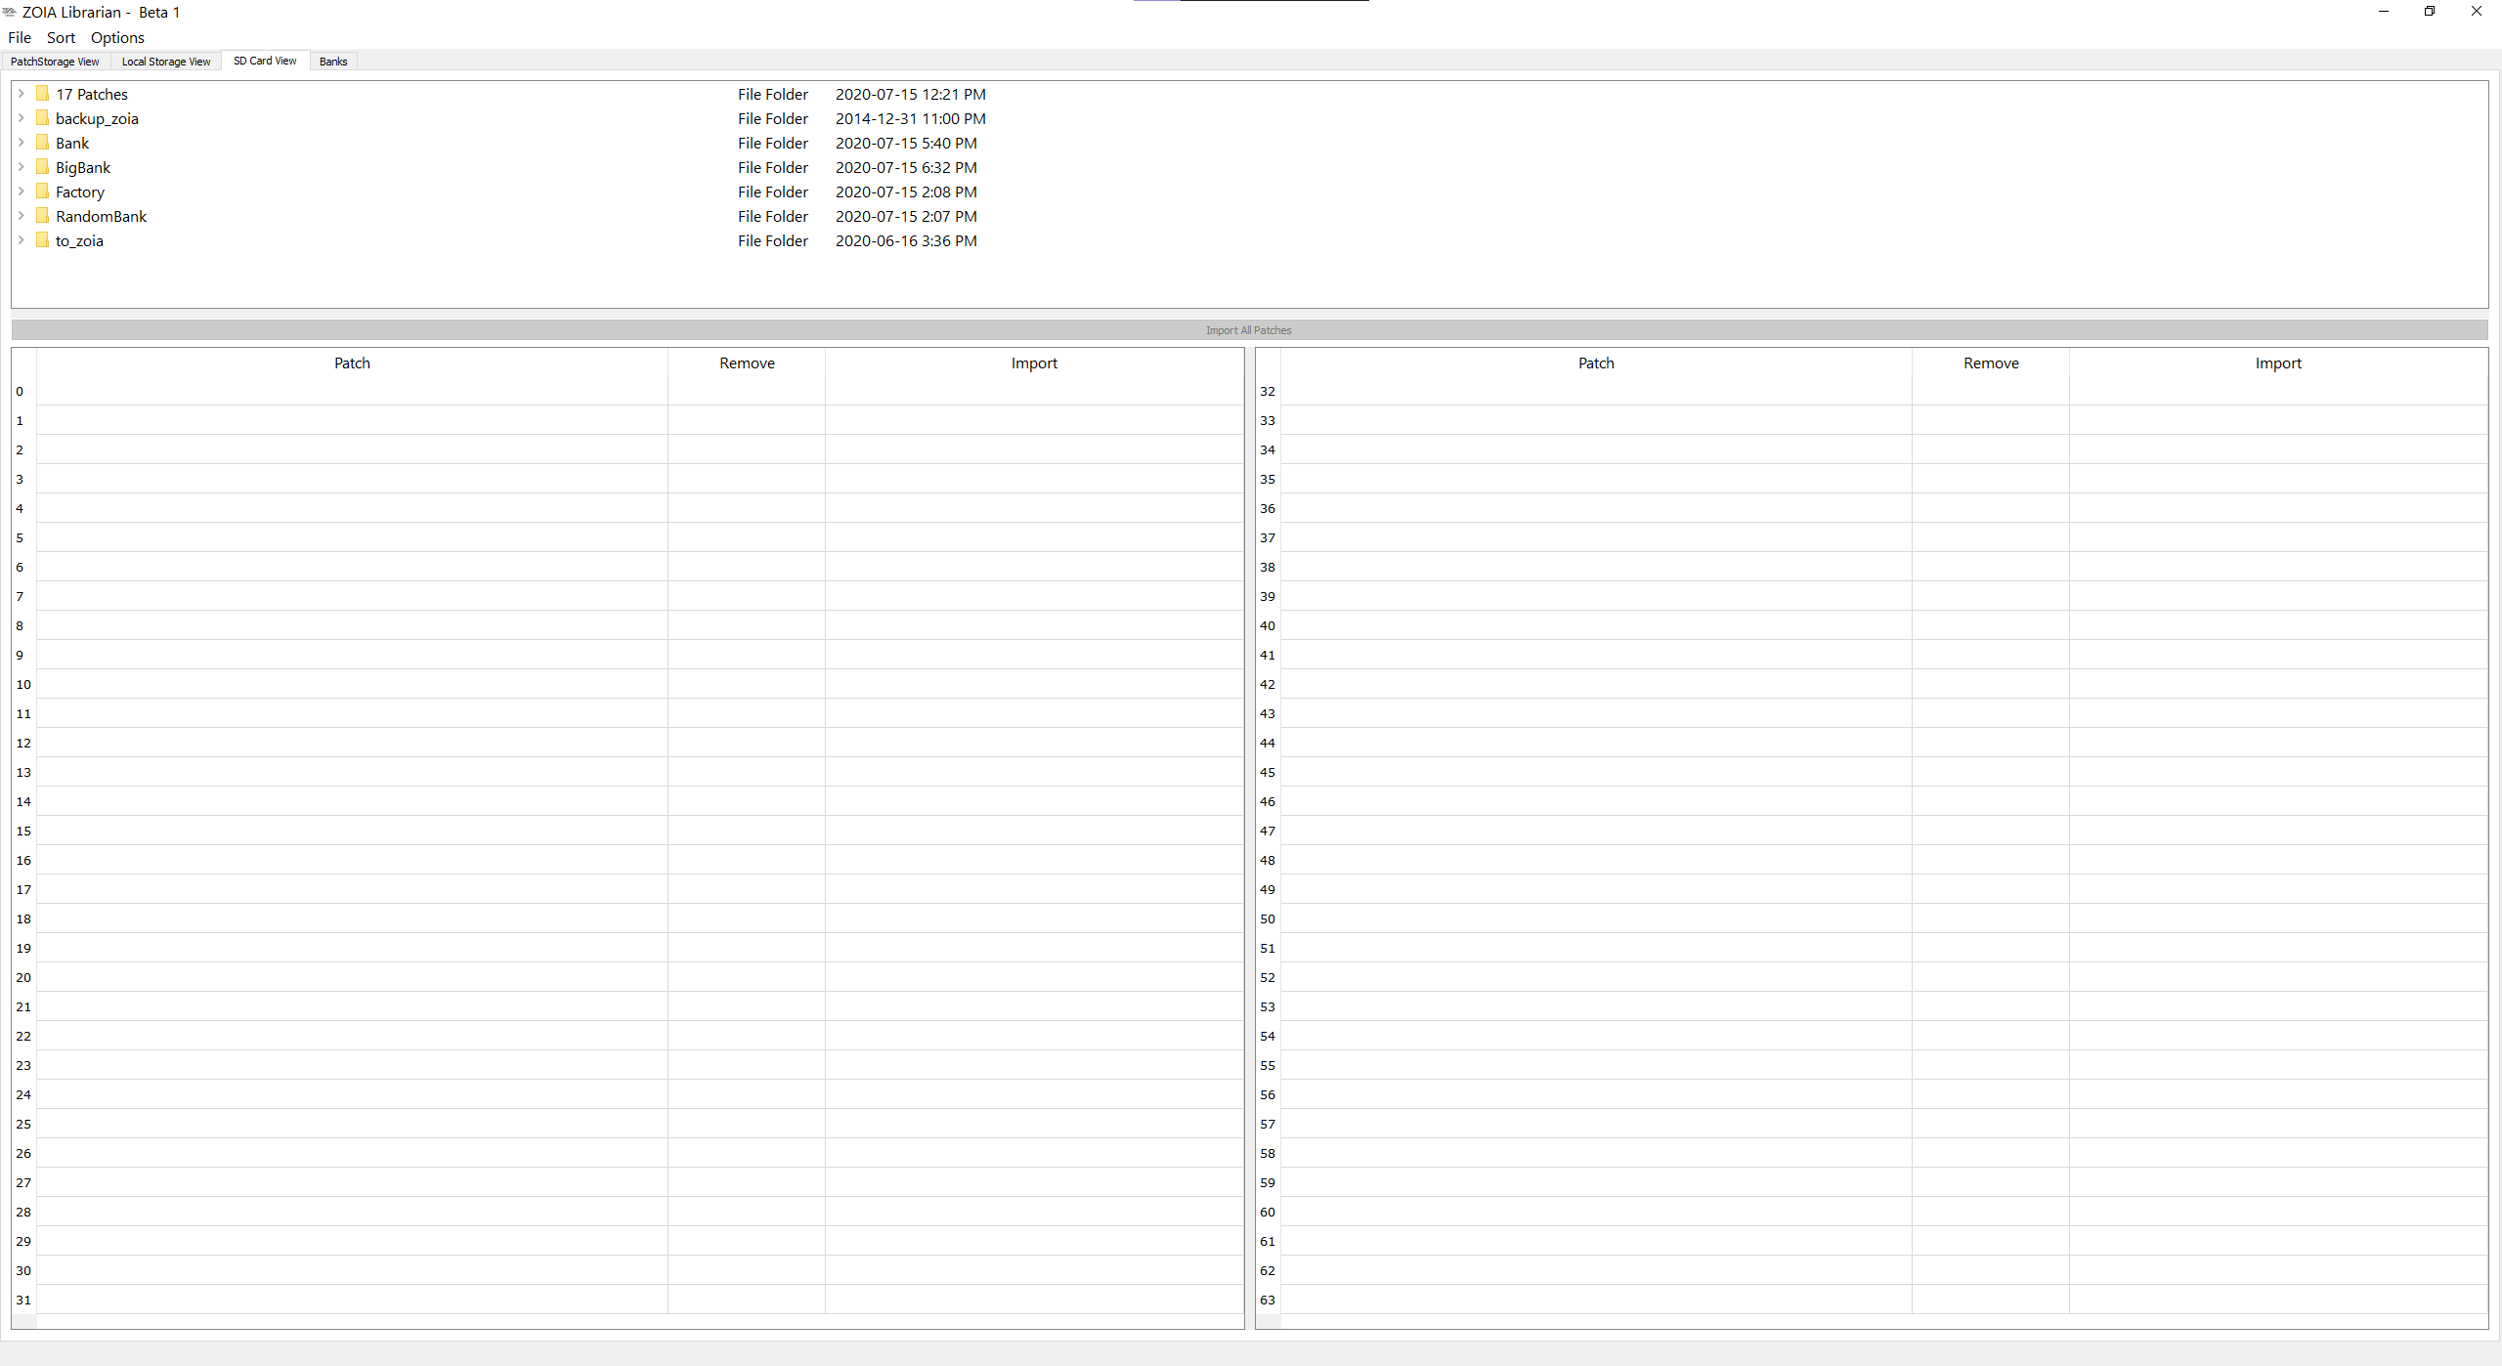Once you enter the SD Card View, this is the screen you will be presented with:

The section of the screen gives you a view of all the folders located on the SD card you specified. You can expand these folders if need be by clicking on the arrow to the left of each folder. However, if you want to have the patches contained within a folder fill the bottom half of the screen, simply left click on the folder you want to view:

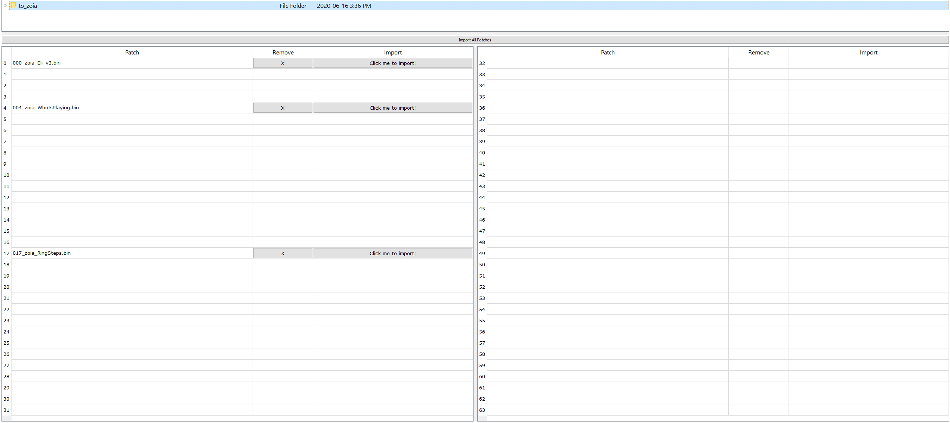

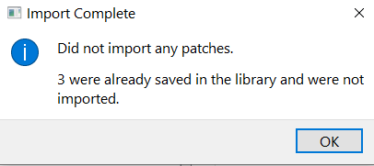You can now move patches by dragging and dropping them into different slots on the SD card. You can also remove a patch from your SD card, or if it is a new patch, you can import it using the Import button. You can also mass import all patches by using the “Import All Patches” button. Please note, if you already have the patches saved in the ZOIA Librarian, the following message will appear:

The SD Card View gives you a quick way to mass import patches from your SD card into the ZOIA Librarian, but what about mass exporting? That is where the Banks tab comes into play, which will be discussed in the next section.

# 1.4 Banks

Upon navigating to the Banks tab, you will be presented with the following screen:

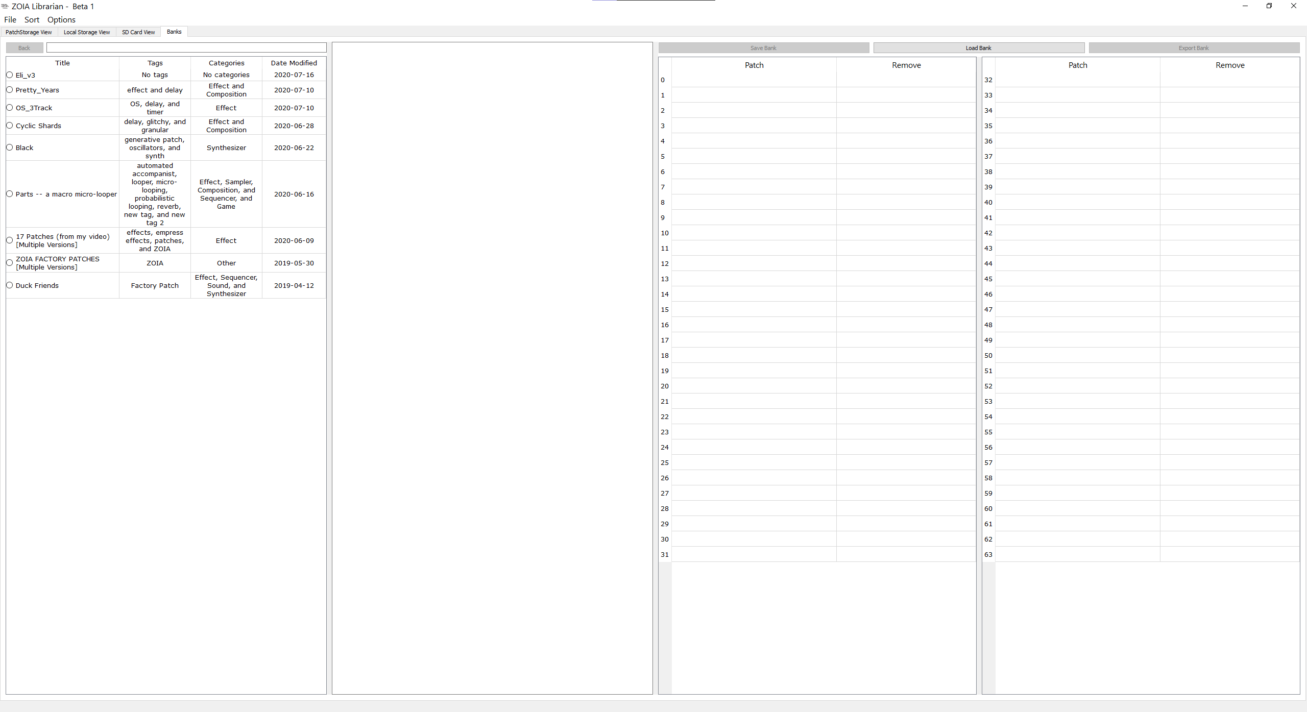

On the left half of the screen, you can view patches saved within the ZOIA Librarian. You can not modify their tags, categories, or patch notes in this view, nor can you delete them. To do so, you will need to go back to the Local Storage View tab. You can still view additional patch information and enter the Version History for patches in the Banks tab. You can also search for patch just as you can in the Local Storage View.

To get started created a bank, select a patch, and drag it over to a slot in one of the two tables of the right-hand side of the screen:

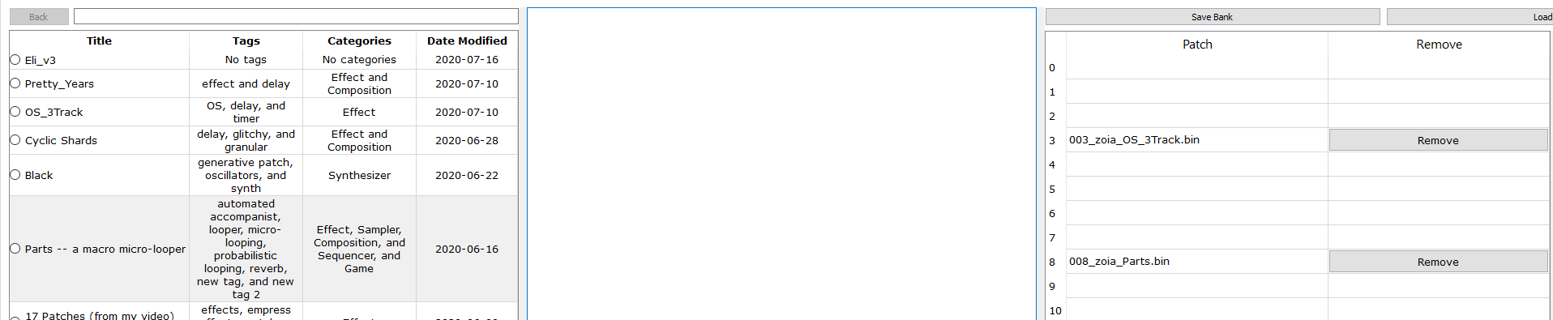

From here, you can move these patches around as you could in the SD Card View. If you drag over a patch that has multiple versions contained within it, it will automatically populate the table with all the patches contained within:

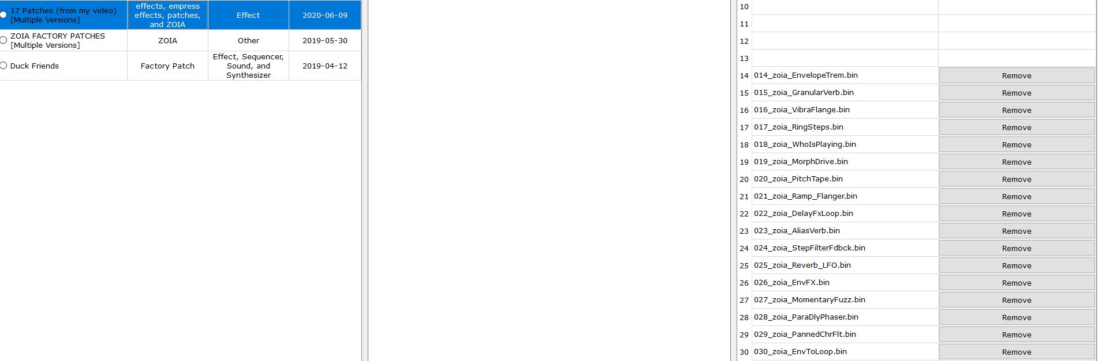

Once you are finished making your Bank, you can either save it using the “Save Bank” button, or export it using the “Export Bank” button. Please note exporting can not occur unless you have specified your SD card. In case you have not specified your SD card yet, look for the “File” option towards the top left of the screen, click it, and then click “Specify SD Card Location”:

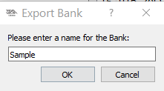Whether you are saving or exporting, you will be asked to provide a name for your Bank:

You will be warned if a folder on your SD card is already using the name you provided. Otherwise, you will be able to find your patch Bank in a new folder on the root of your SD card.

# 1.5 Additional Features

There are some additional features that are available in the ZOIA Librarian, such as patch importing options, sorting options, and a table row inversion option. We hope these features makes using the ZOIA Librarian even easier for you.

# 1.6 Future Plans

As this is an initial beta, there is still a lot of work to be done. The overall look and feel of the ZOIA Librarian is pretty bare right now, so if you have any suggestions surrounding the design of things, please let us know. For Beta 2, here are some of the planned features we hope to add:

* Saving application settings when you quit (so you will not need to re-specify your SD card every time if its in the same spot as before).
* Adding font options (such as the ability to scale the size and change the font that is used in the tables).
* Adding accessibility text to everything in the ZOIA Librarian.
* Adding the ability to update the author, preview link, and licence for patches in the Local Storage View.
* Improving the patch preview page to include images authors have uploaded alongside their patches.
* Adding the ability to drag and drop multiple patches at a time in the SD Card View and Banks tabs.
* Performance improvements to prevent the application from freezing up when certain actions have taken place (such as checking for updates or refreshing the PatchStorage patch list).

We encourage you to provide feedback on things you want to see changed or features you would like to see added. Thank you for being an awesome member of the ZOIA community!